Town of Nichols
Town Board Meeting
Public Hearing’s
February 28, 2018

Supervisor Engelbert brought meeting to order at 7:00 pm in the Town Hall, located at 54 East River Rd. Nichols NY.

Pledge of Allegiance;

Roll Call:
Councilperson Ray Thetga (absent), Councilperson Bill Middleton (present), Councilperson Esther Woods (present), Councilperson Barbara Crannell (present), Kevin Engelbert (present), Karen Hunsinger Town Clerk.

Also present; Lesley Pelotte, Roseann Cole, Kara Steele, Ezra Steele, Teresa Ryder, and Warren Howler

QUESTIONS, COMMENTS & CRITICISMS FROM THE PUBLIC
Drone Ordinance – Kara Steele and Ezra Steele were present to discuss the Drone Ordinance, Ezra is interested in becoming an Engineer and has built his own drone, and is concerned of restrictions of flying drones, if property owned by owner is only a few acres and can be seen in entirety by the bare eye it’s redundant to fly a drone over same area for aerial views, privacy concerns, most drones have a wide angel camera and are not equipped for viewing in windows etc… as a responsible drone owner Ezra uses his drone to see wildlife, landscapes, and take nature pictures, google earth is comparable to drones.
Eliminating the camera from the drone would be like a remote control toy car/truck.
Permission from neighbors, would that have to be given every time drone was flown or once a month/year?

Board – the Drone Ordinance is not to punish responsible owners of drones, but to protect people’s property rights. Asking permission from neighbors to fly drone on their property may be an inconvenience at the time but will protect both parties.

MINUTES
The motion to approve minutes from February 13, 2018 with corrections, made by B. Crannell, 2nd by B. Middleton
Roll Vote;
B. Middleton, (aye), E. Woods (aye), B. Crannell (aye), K. Engelbert (aye) passed 4-0-1absent

NEW BUSINESS
Public Hearing – Local Law #2 – 2018 – Solar Energy Systems Ordinance Supervisor Engelbert opened the Public Hearing at 7:00 pm.
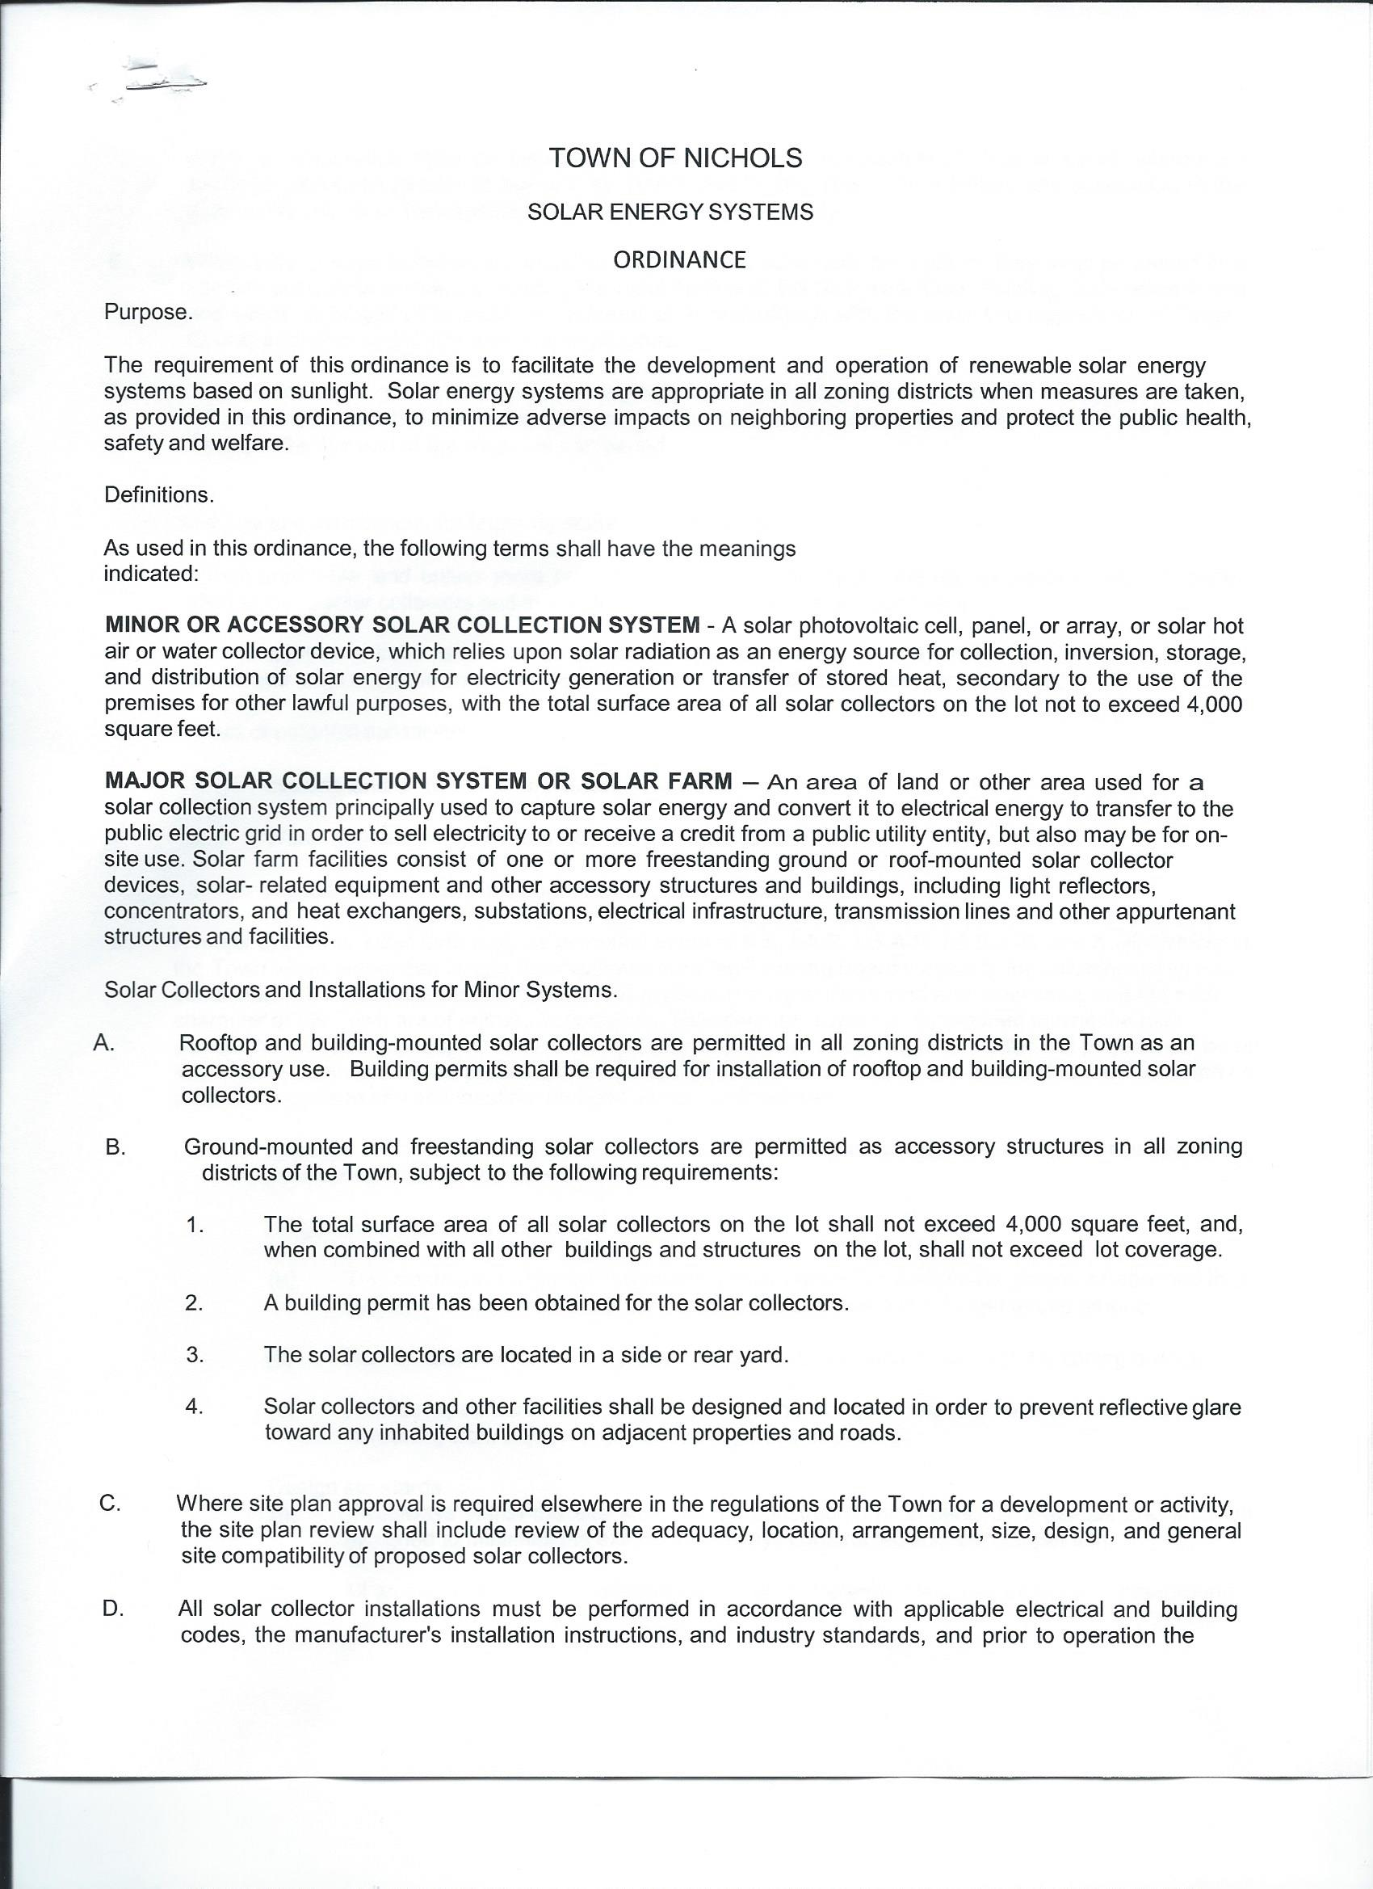
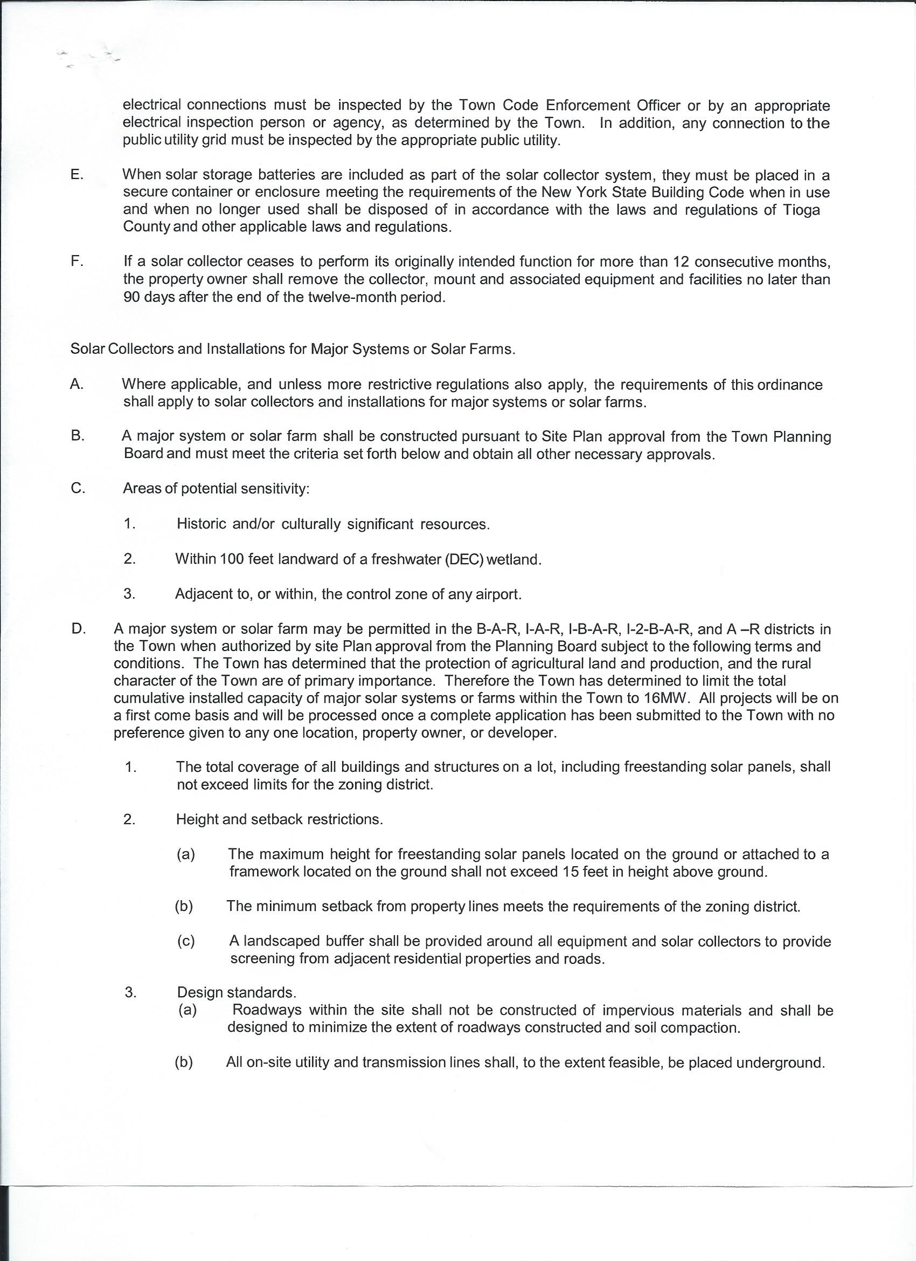

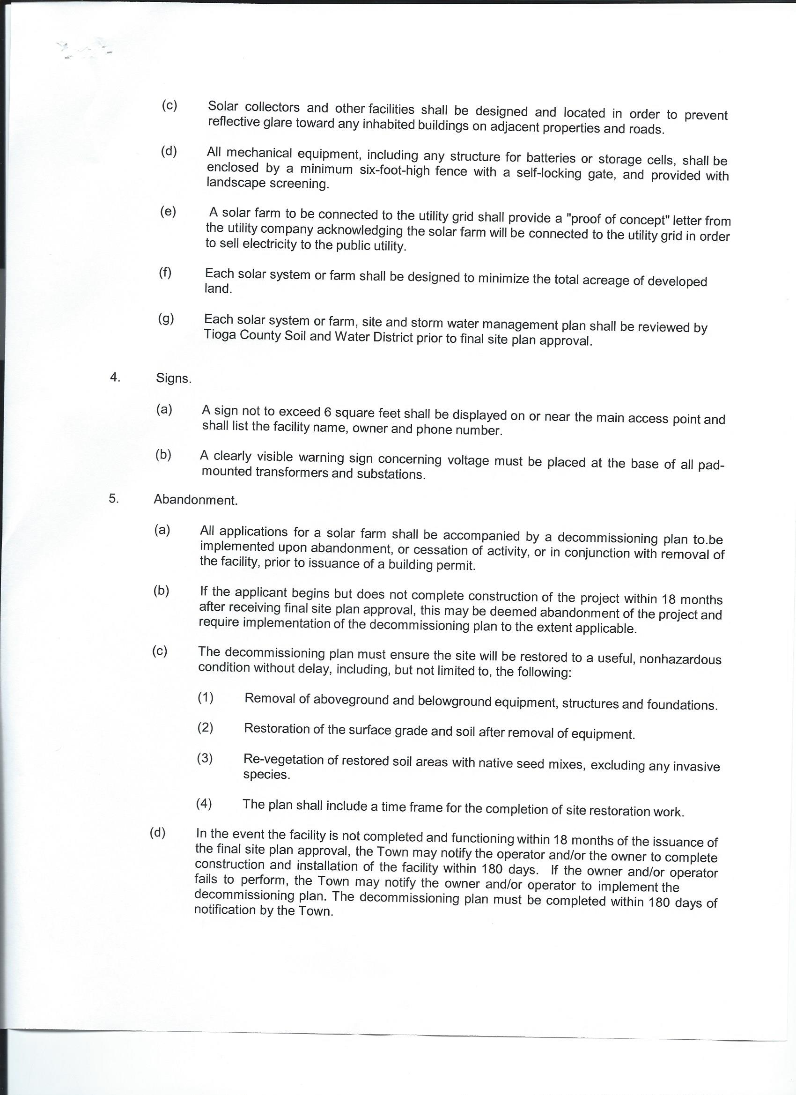

Supervisor Engelbert opened floor for discussion of Local Law # 2 -2018 Solar Energy Systems
Supervisor Engelbert closed Public Hearing at 7:03 pm
Roll Vote;
B. Middleton, (aye), E. Woods (aye), B. Crannell (aye), K. Engelbert (aye) passed 4-0-1absent

Public Hearing - Supervisor Engelbert opened the Public Hearing at 7:05 pm. for
Local Law #3 – 2018 – Drone (Unmanned Aircraft System) Ordinance
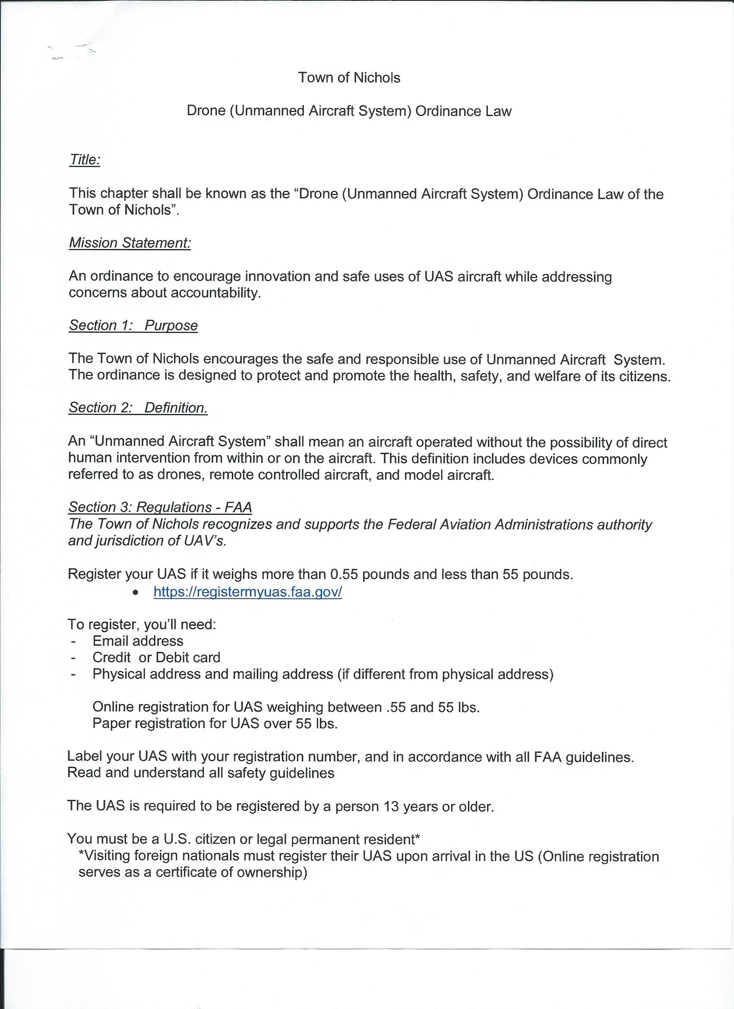

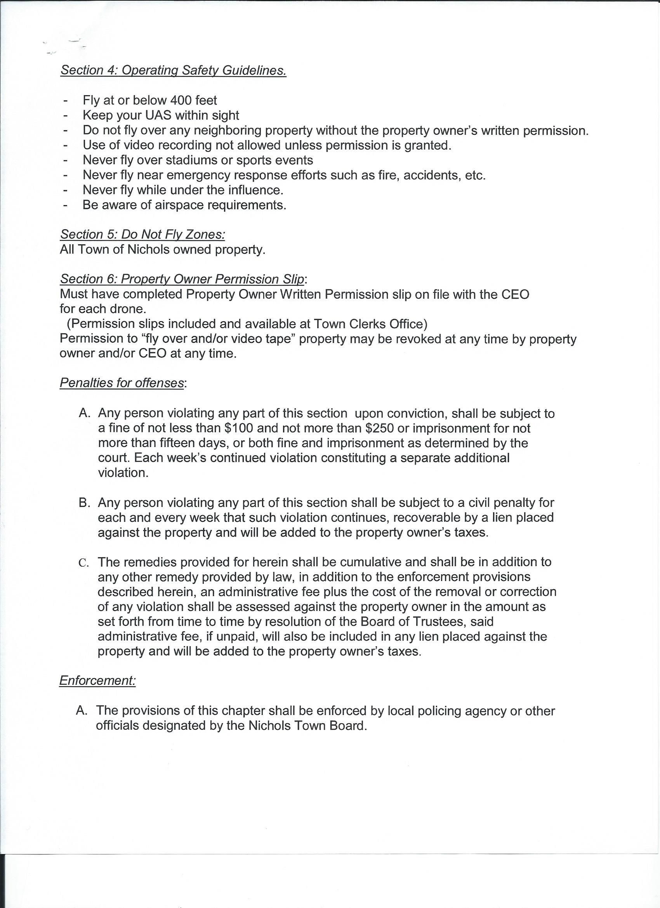

Supervisor Engelbert opened floor for discussion of Local Law # 3 -2018 Drone Ordinance
Supervisor Engelbert closed Public Hearing at 7:08 pm
Roll Vote;
B. Middleton, (aye), E. Woods (aye), B. Crannell (aye), K. Engelbert (aye) passed 4-0-1absent

Public Hearing - Supervisor Engelbert opened the Public Hearing at 7:10pm. for Street Lighting on West River Rd. A discussion ensued about the proposed street lighting on West River Rd. poles on West River Rd from the 282 intersection down West River Rd. to Tioga Downs.
The motion was made to approve Street Lighting on West River Rd. from the 282 intersection to Tioga Downs Casino, with the provision that the Town of Nichols will be responsible for NYSEG bills for Street lighting unless or until there is a drop in the percentage of gross gaming Revenues from Tioga Downs, at which time Tioga Downs will then be responsible for NYSEG bills for Street lighting.
Motion made by B. Middleton 2nd by E. Woods
Roll Vote;
B. Middleton, (aye), E. Woods (aye), B. Crannell (aye), K. Engelbert (aye) passed 4-0-1absent

Public Hearing – Supervisor Engelbert opened the Public Hearing at 7:15pm for Local Law # 4 2018 Updating Building Codes from 2012 code to 2016 code of NYS Building Code.
Motion made by B. Crannell 2nd by B. Middleton
Roll Vote;
B. Middleton, (aye), E. Woods (aye), B. Crannell (aye), K. Engelbert (aye) passed 4-0-1absent

The motion was made to Set Time and date for Public Hearing’s for the Zoning Change, and Site Plan Review.
Public Hearing for the Site Plan Review will be set for March 28, 2018 at 7:00 pm
And the Public Hearing for the Zoning Change will be set for March 28, 2018 at 7:10pm
Motion made by B. Middleton 2nd by B. Crannell
Roll Vote;
B. Middleton, (aye), E. Woods (aye), B. Crannell (aye), K. Engelbert (aye) passed 4-0-1absent

Supervisor Engelbert received a Thank You Note from Community Care Network of Nichols (CCNN) Thanking the Town for its support.

APPOINTMENTS
The motion was made to appoint three (3) new members to the Library Board, with know term limit, as there are no term limits for the Library Board. The new members are as follows
Mary Gleason, John Kapaco, and Sally Schoonover.
The motion was made by B. Crannell 2nd by B. Middleton
Roll Vote;
B. Middleton, (aye), E. Woods (aye), B. Crannell (aye), K. Engelbert (aye) passed 4-0-1absent

Recognition of Appreciation to Joanne Stevens for Thirty Three (33) years of dedicated service as a Library Board Member.
Motion was made to authorize Supervisor Engelbert to sign and present Joanne Stevens with an Appreciation Certificate for her dedicated service as a Library Board Member. Made by B. Crannell 2nd by E. Woods
Roll Vote;
B. Middleton, (aye), E. Woods (aye), B. Crannell (aye), K. Engelbert (aye) passed 4-0-1absent

OTHER NEW BUSINESS FROM BOARD MEMBERS

UPDATE FROM TOWN DEPARTMENTS/PERSONNEL

- Planning Board – B. Crannell
No meeting was held

OLD BUSINESS

- 2018 Mowing Bids –
No bids have been received by Town Clerk.

- Council of Government – B. Crannell
Stray Haven contract was to be increased in 2019 for all Municipalities from $800.00 per year to $1,500.00 per year not $15,000.00 per year. $100.00 per dog for holding fees with minimum of $100.00 per year in holding fees per year.

- NY Rising/Comprehensive Plan – B. Crannell

- REAP – B. Crannell
A meeting will be held on March 21, 2018 to discuss with County, collaboration County wide for shared services.
- Update on Highway Garage – K. Engelbert
Bids are out – bid packet from GOSR – a pre bid meeting has been set for March 15, 2018 at 2:00 pm at the Town Hall.

OTHER OLD BUSINESS FROM BOARD MEMBERS

- Town Clerk to run ad in all three (3) Town papers for new hours.

ACCEPT REPORTS AND PAY BILLS
The motion was made to accept the reports and pay bills by B. Crannell 2nd by E. Woods
Roll Vote;
B. Middleton, (aye), E. Woods (aye), B. Crannell (aye), K. Engelbert (aye) passed 4-0-1absent

ADDITIONAL QUESTIONS, COMMENTS &CRITICISMS FROM THE PUBLIC

EXECUTIVE SESSION

ADJOURN
The motion to adjourn the meeting at 7:50 pm made by B. Middleton 2nd by E. Woods
Roll Vote;
B. Middleton, (aye), E. Woods (aye), B. Crannell (aye), K. Engelbert (aye) passed 4-0-1absent

Karen Hunsinger
Town Clerk
03/08/2018

