Town of Nichols
Regular Board Meeting
Public Hearing’s
July 10, 2018

Supervisor Engelbert brought meeting to order at 7:00 pm in the Town Hall, Located at 54 E. River Rd. Nichols NY.

Pledge of Allegiance;

Roll Call;
Councilperson Ray Thetga (present), Councilperson Bill Middleton (present), Councilperson Esther Woods (absent), Councilperson Barbara Crannell (present), Kevin Engelbert (present), Karen Hunsinger Town Clerk.

Also present; Lesley Pelotte (Village Mayor), Karl Ray (GOSR), Matt Freele (Morning Times), Tim Steed (Hunt Engineers), Ryan Middleton, Bruce and Kristen Peters.

MINUTES
The motion to approve the minutes from June 27, 2018, made by B. Crannell 2nd by B. Middleton.
Roll Vote;
R. Thetga (aye), B. Middleton (aye), B. Crannell (aye), K. Engelbert (aye). Carried 4-0-1-0

CEO REPORT - Was submitted and is on file in the Clerk’s Office.

CLERKS REPORT – Was submitted and is on file in the Clerk’s Office.

DCO REPORT - Was submitted and is on file in the Clerk’s Office.

SUPERVISORS REPORT – Was submitted and is on file in the Clerk’s Office.

JUSTICE REPORT - Justice Byers
June Report
Fines $23,663.00
Surcharges $12,025.00
Civil Fees $ 3,240.00
Total $38,928.00
Total Cases 279

QUESTIONS, COMMENTS & CRITICISMS FROM THE PUBLIC
Ryan Middleton – discuss Horton Rd.
The road is too narrow for emergency vehicles to get to his house, he wants to know what steps to be taken to get the road worked and widened for easy access for large vehicles, such as emergency, fire and ambulance’s.
Kevin Vought – stated he looked at and measured Horton Rd. and the road is 16 ft. in width, to make road wider an electric pole on Bill Middleton’s property will have to be moved and relocated. K. Vought will call association of Town’s to look into laws for secondary roads, as to what has to be done.
Ryan Middleton – the Road needs to be fixed, in winter it is hard to travel, because of T coming off Mt. Pleasant and sharp corner at the top of the road.
Kevin Vought – Highway Department can look at road again, but are busy on other roads at present time. K. Vought stated he doesn’t want to start it unless they can get it completed or in better shape before winter, it will take at least a year to widen and grade road properly.
Kristen Peters- Her husband Bruce is disabled and they need to be able to get emergency vehicles to their home.

NEW BUSINESS
- Easements for Village – (Tim Steed & Lesley Pelotte)
Mr. Tim Steed -Hunt Engineering, was present to present blue prints of a generator and where it would be installed at the NES building owned by the Town of Nichols. The Town and Village of Nichols have designated the NES building as an Emergency Shelter in case of disaster, and in doing so the building will need to be updated for such disasters, with a generator large enough to run electric, water and a full commercial Kitchen.
Village Mayor Leslie Pelotte has made application through Government of Storm Recovery (GOSR) for the purchase and installation of a secure self - enclosed commercial generator and 2 propane tanks that will be installed underground with propane lines to the generator buried for safety for the NES building. Since the NES building is the property of the Town of Nichols, the Village and GOSR need an easement for the placement of the generator on their property.

A motion was made by the Nichols Town Board, of intent to grant an easement to the Village of Nichols and authorized the Town Attorney to draft an easement for a commercial generator at the NES building. Made by K. Engelbert 2nd by B. Middleton.
Roll Vote;
R. Thetga (aye), B. Middleton (aye), B. Crannell (aye), K. Engelbert (aye) Carried 4-0-1-0

- Aluminate Sign – Village Mayor Leslie Pelotte has made application through Government of Storm Recovery (GOSR) for the purchase and installation of an aluminate sign for emergency warnings and information for the Village and Towns use to be installed by the Towns bulletin board located next to the Community Bank in the Village of Nichols. The Town of Nichols own the property where the sign is to be located and the Village and GOSR need an easement from the Town of Nichols to place the sign on their property.

A motion was made by the Nichols Town board, of intent to grant an easement to the Village of Nichols and authorized the Town Attorney to draft an easement for an aluminate sign on the property on East River Rd, owned by the Town of Nichols. Made by K. Engelbert 2nd by B. Middleton.
Roll Vote;
R. Thetga (aye), B. Middleton (aye), B. Crannell (aye), K. Engelbert (aye). Carried 4-0-1-0

- Highway Garage – (Karl Ray, GOSR) – Update on Highway Garage
GOSR needs either a Resolution or the Garage project will have to go back out to bid. There were unforeseen problems with the original bid but if the Town does a resolution accepting the single bids and the timing of publication and accept the process that was followed the bid process will go through and GOSR will accept the resolution and the single bids for the project.

A discussion ensued with board over which path to take; rebid or resolution. Some concerns were brought up and opinions/answers were given by lawyer or GOSR rep. Karl Ray.

The motion to go to Attorney/Client session at 7:50 pm, made by K. Engelbert 2nd by B. Middleton.
Roll Vote;
R. Thetga (aye), B. Middleton (aye), B. Crannell (aye), K. Engelbert (aye). Carried 4-0-1-0

The motion to come out of Attorney/Client session at 8:00 pm, made by B. Middleton 2nd by R. Thetga.
Roll Vote;
R. Thetga (aye), B. Middleton (aye), B. Crannell (aye), K. Engelbert (aye). Carried 4-0-1-0

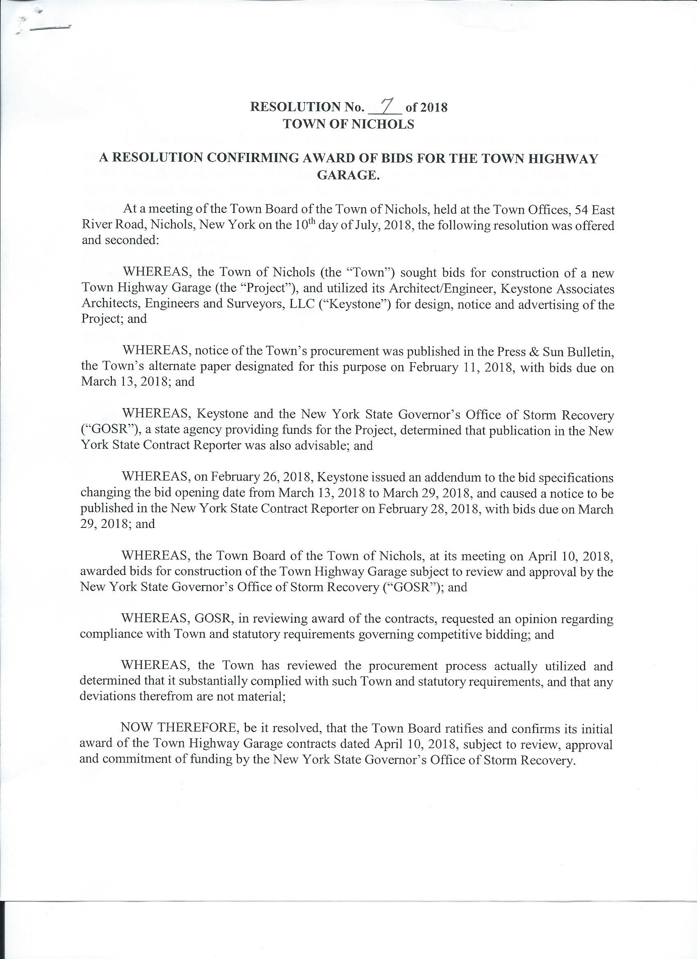
The motion to accept Resolution #7 – 2018, Made by B. Middleton 2nd by R. Thetga.
Roll Vote;
R. Thetga (aye), B. Middleton (aye), B. Crannell (aye), K. Engelbert (no). Carried 3-1-1-0

- Estimates for repairing lights at NES gym – B. Middleton
There are 8 lights in gym and 4 are not working. One estimate was received from Patterson Electric with 2 estimates ;
Repair 4 broken light fixtures $1,599.48
Replace all 9 M/H Bulbs and Ballast with 9 LED Bulbs $2,926.28
The motion was made to approve replacing all 9 fixtures with LED Bulbs, made by R. Thetga 2nd by B. Crannell.
Roll Vote;
R. Thetga (aye), B. Middleton (aye), B. Crannell (aye), K. Engelbert (aye). Carried 4-0-1-0

- Supervisor Engelbert opened Public Hearing at 8:32pm at the Regular Town Board Meeting at the Town Hall, located at 54 E. River Rd. Nichols NY.
Supervisor Engelbert opened the floor for Discussion of the Following Local Law.
No discussion.
Public Hearing
Local Law #5
A Local Law Repealing and Replacing Local Law 2-2018 Entitled
“Solar Energy Systems” and Amending Chapter 194 “Entitled Zoning”

Supervisor Engelbert closed Public Hearing at 8:33pm

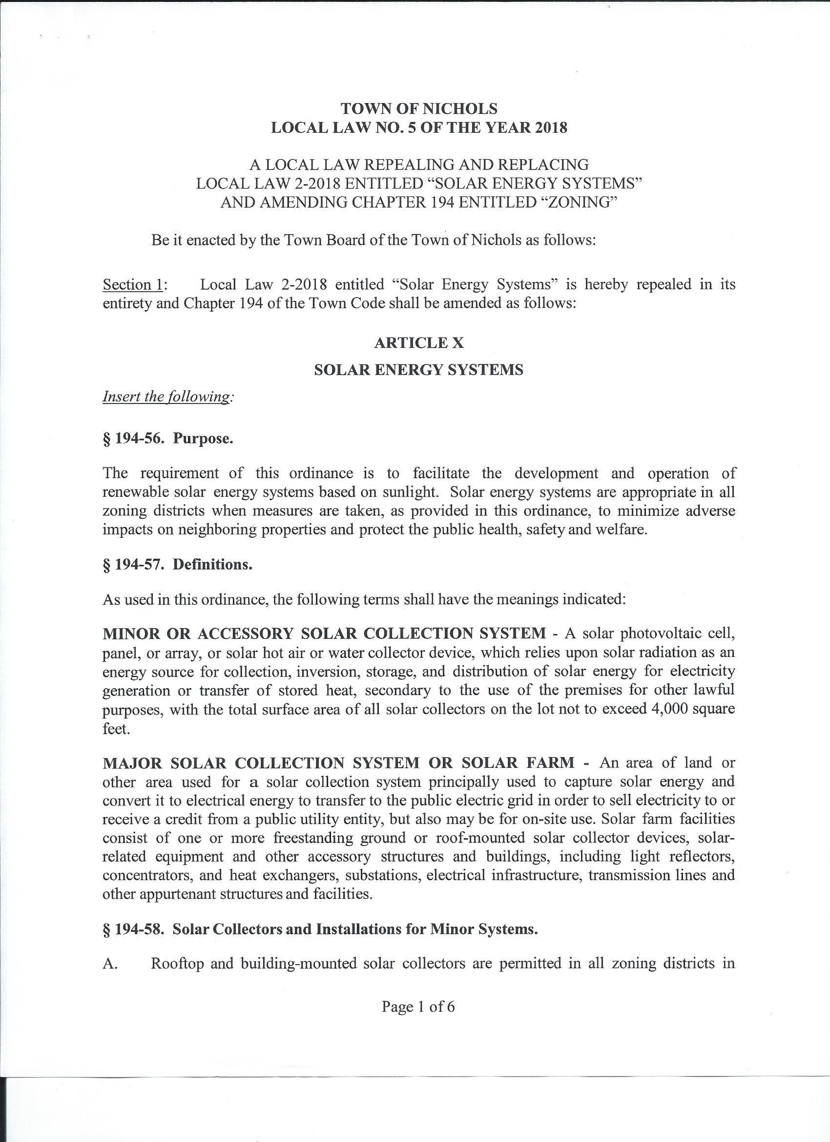
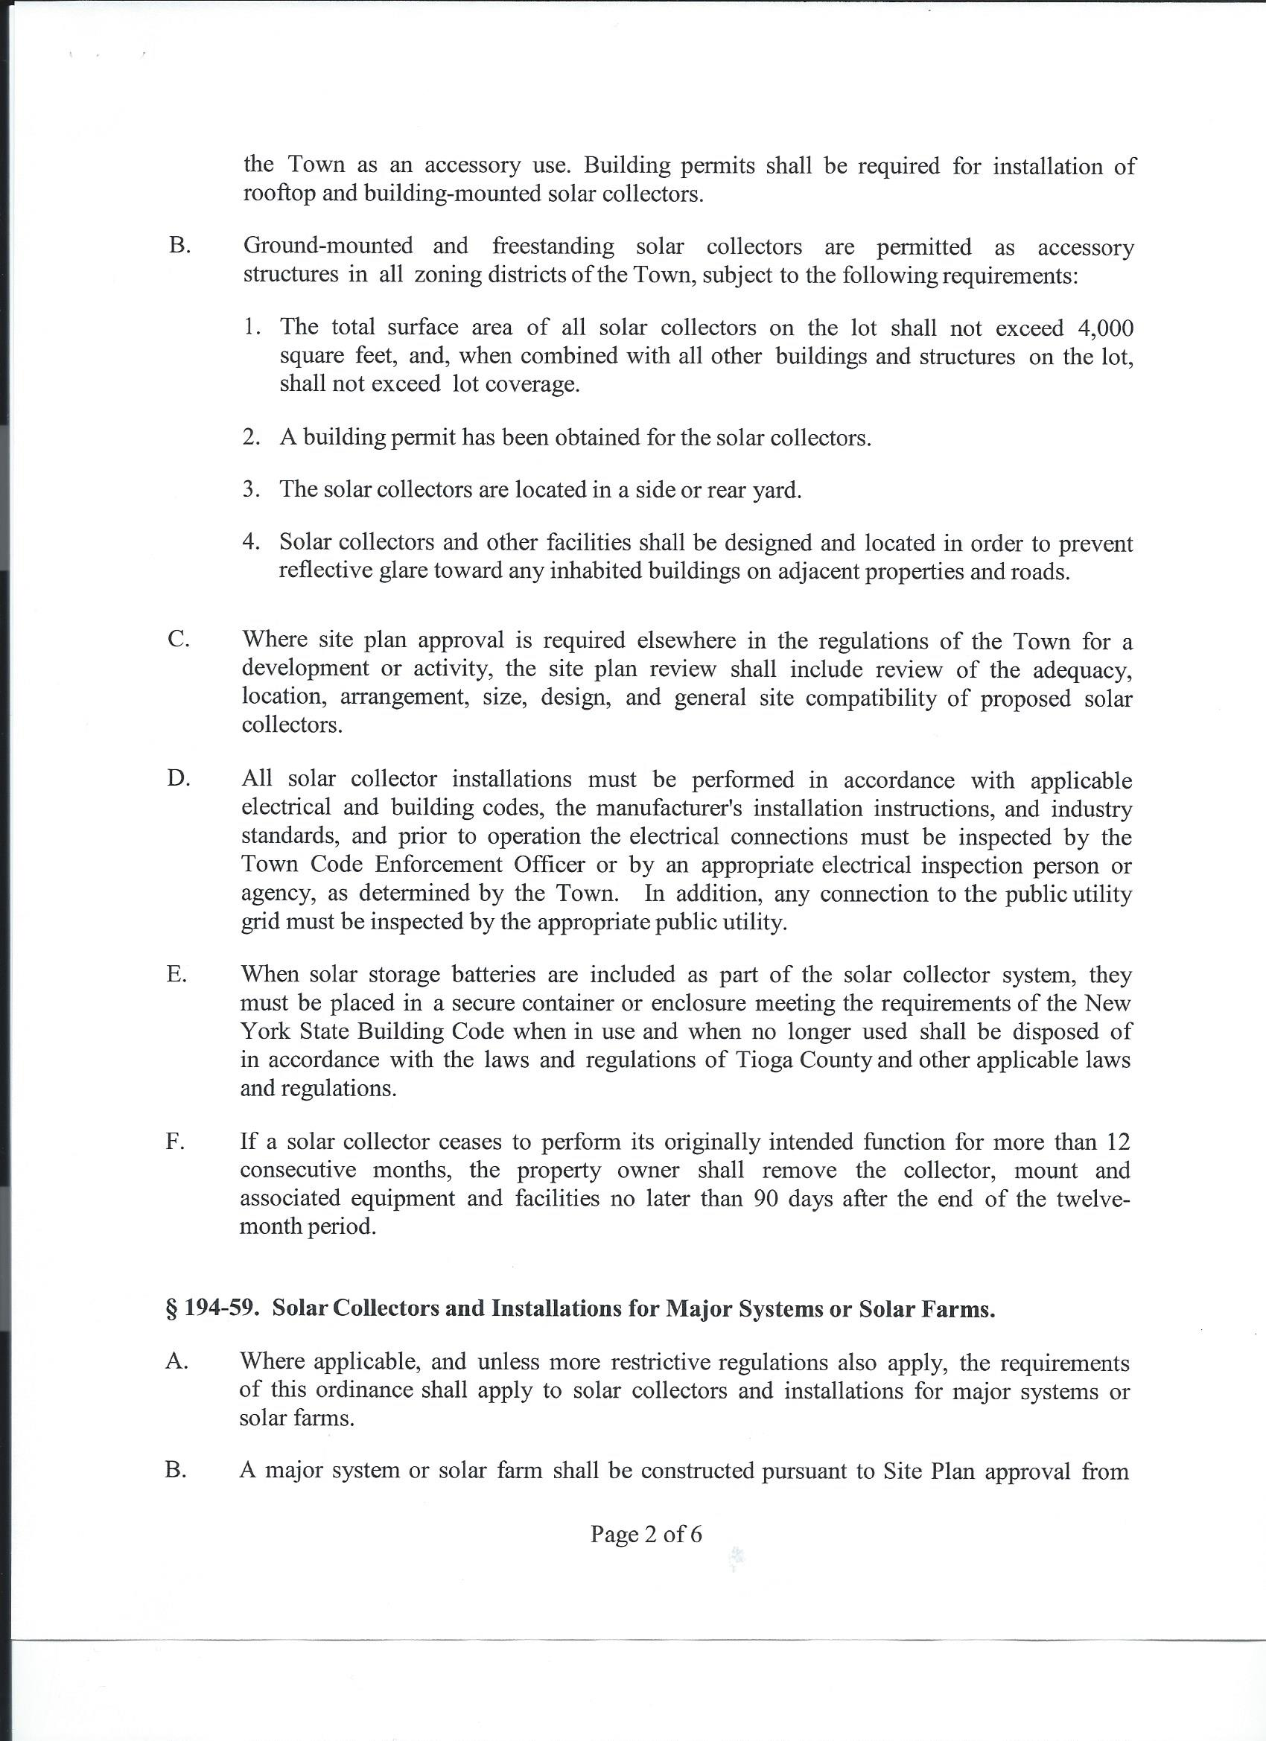
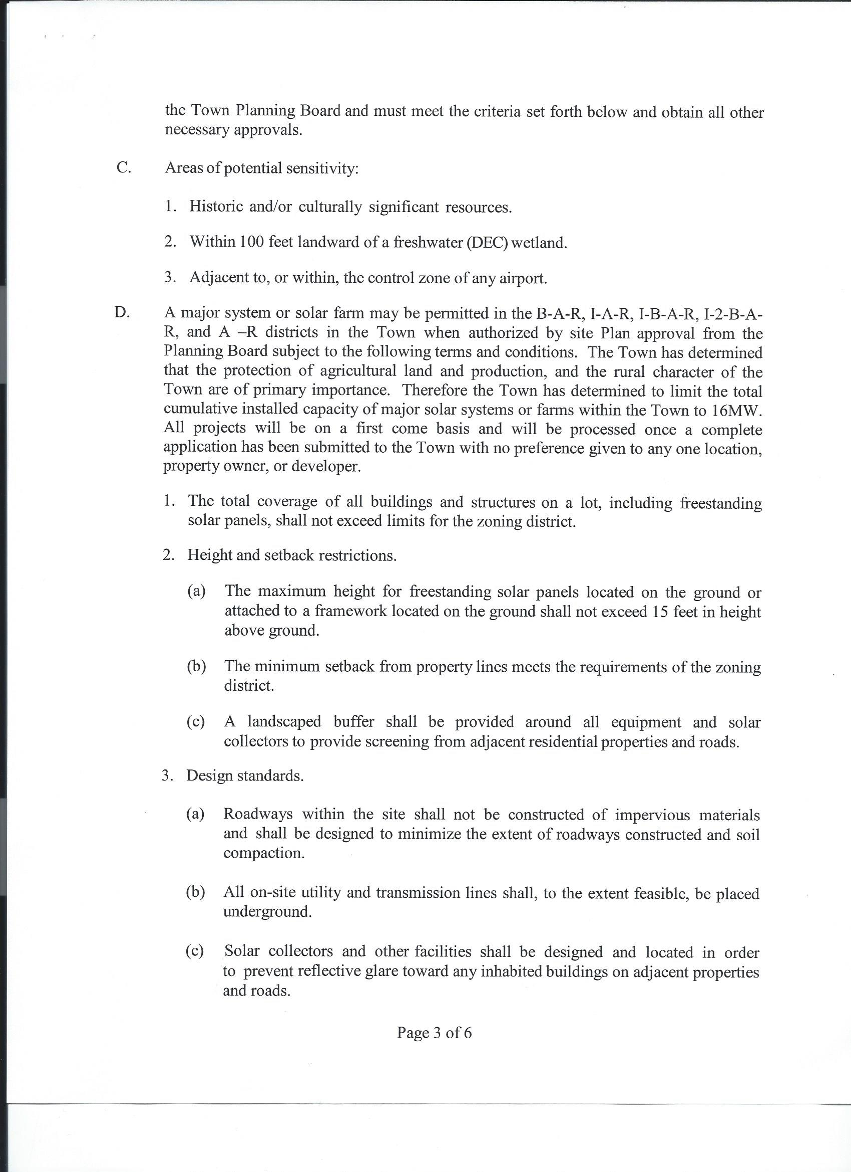
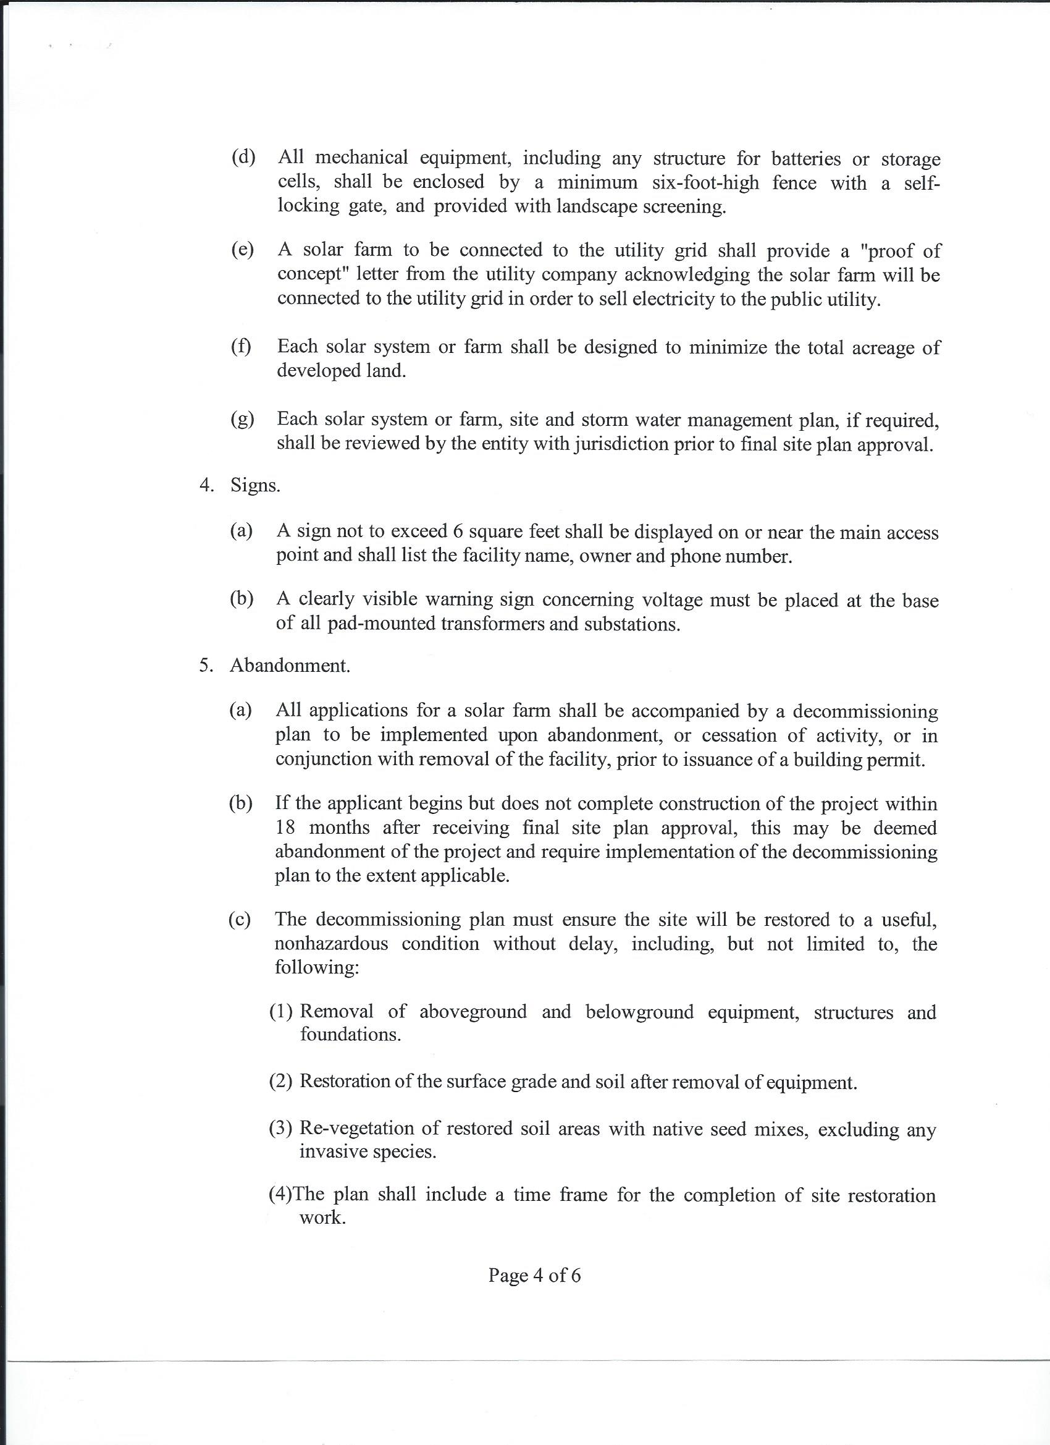
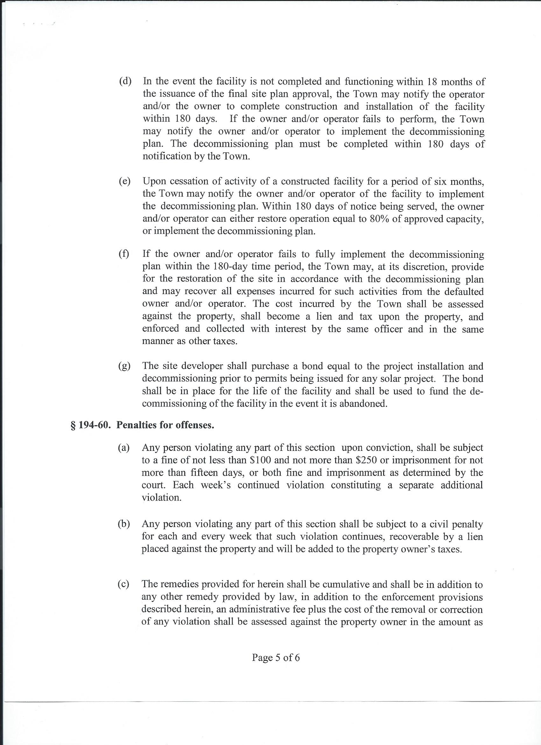
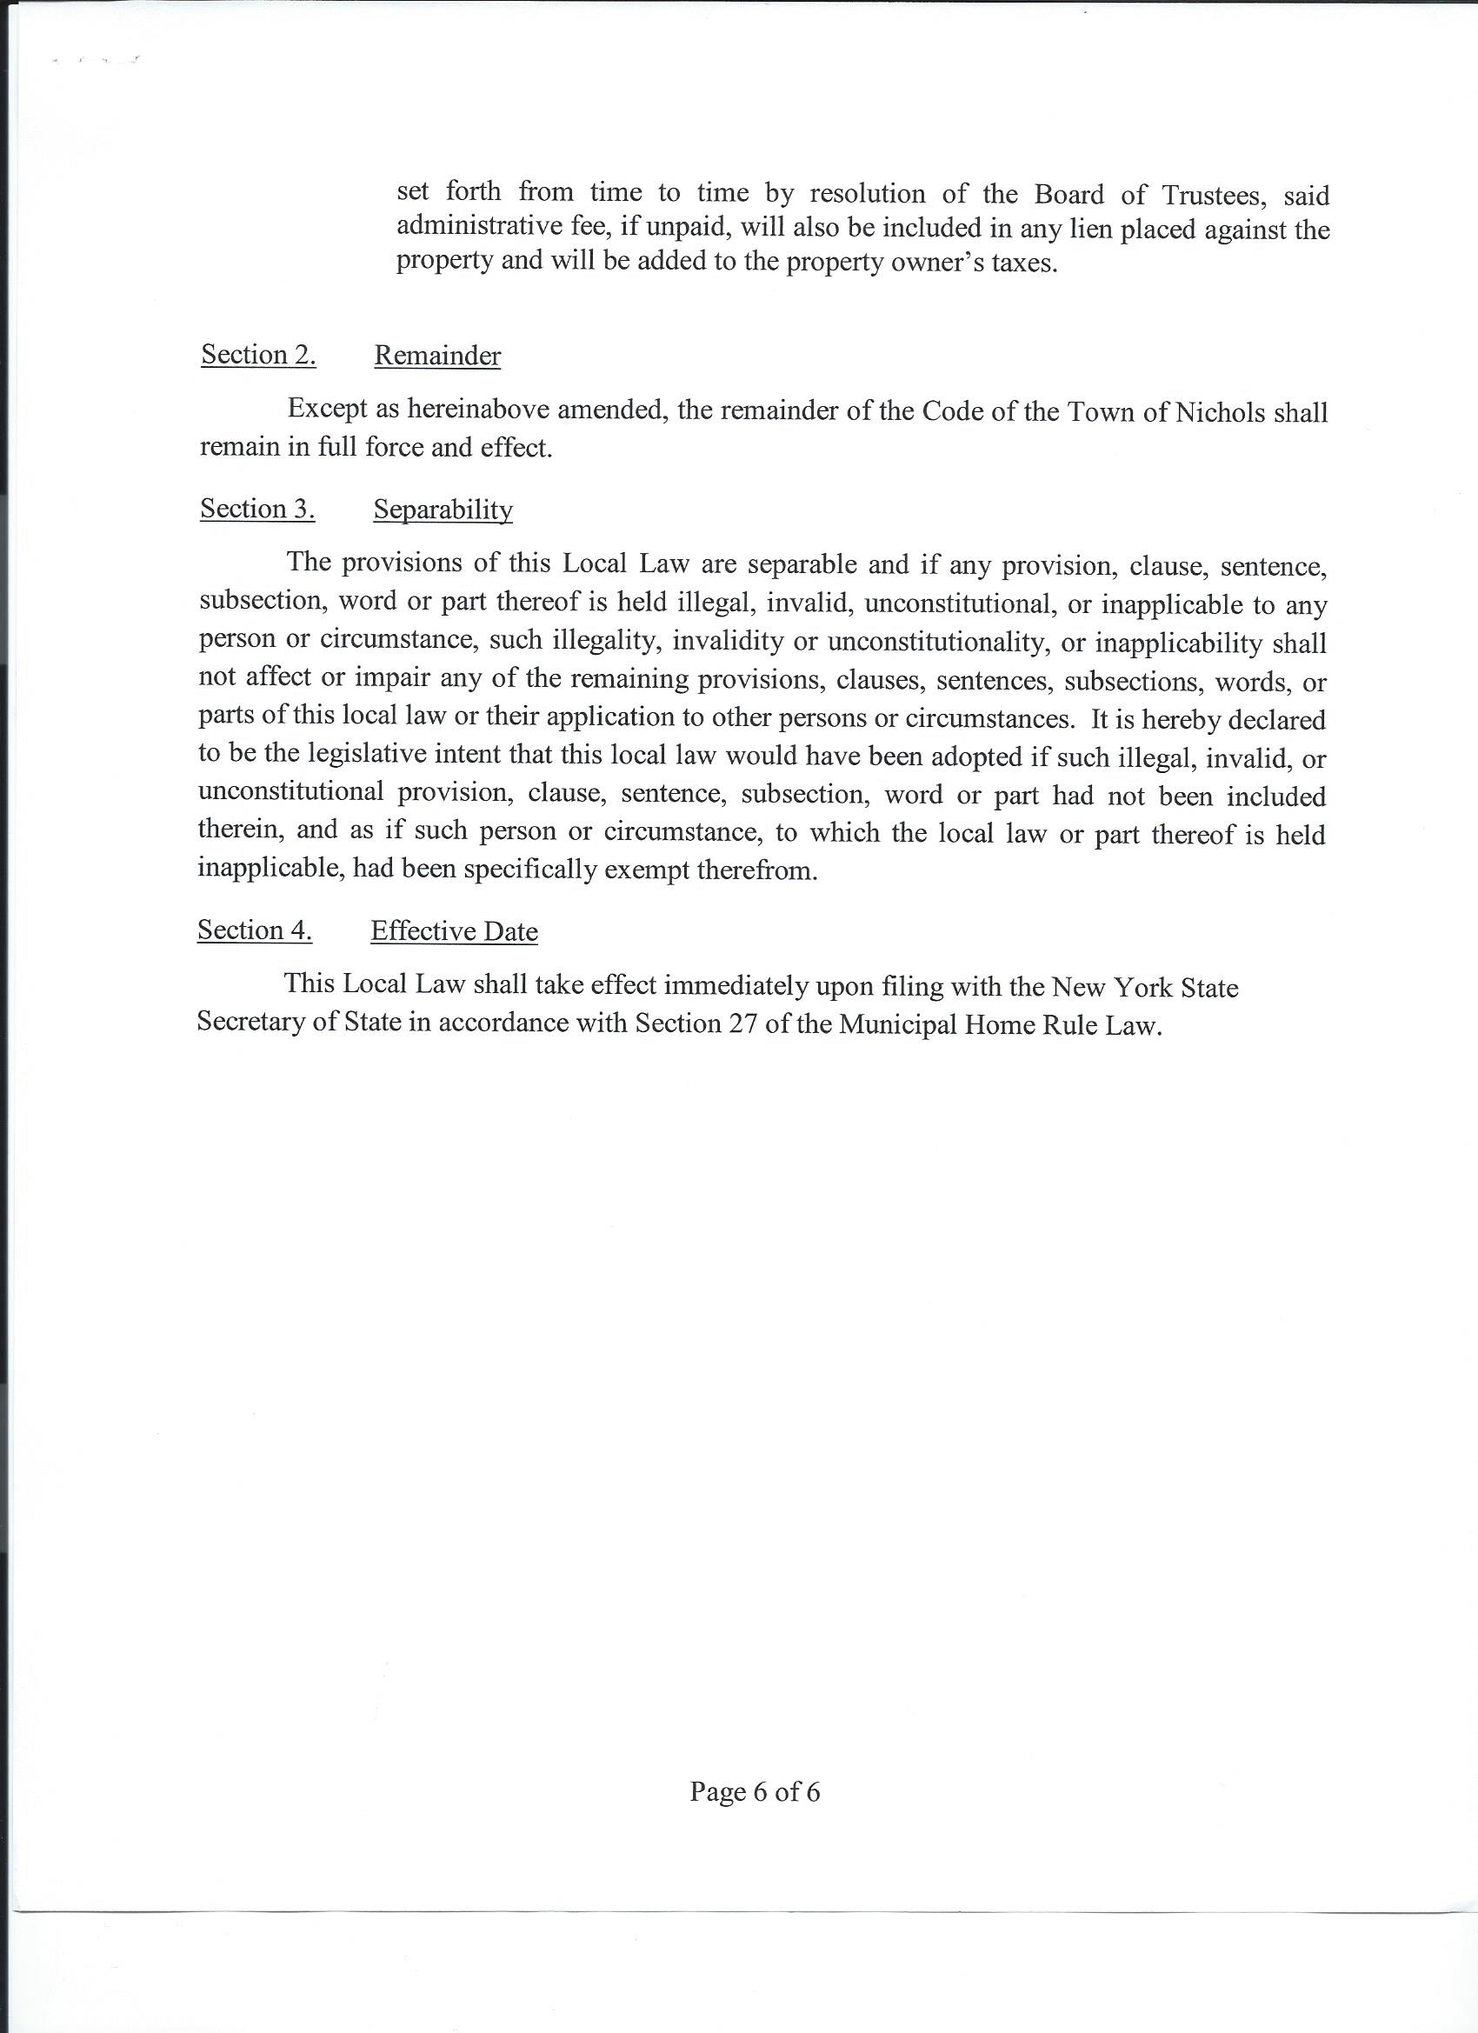
The motion to approve Local Law #5 – A Local Law Repealing and Replacing Local Law #2-2018 Entitled “Solar Energy Systems” and Amending Chapter 194 Entitled “Zoning”
Was made by B. Middleton 2nd by B. Crannell
Roll Vote;
R. Thetga (aye), B. Middleton (aye), B. Crannell (aye), K. Engelbert (abstain). Carried 3-0-1-1

- Supervisor Engelbert opened Public Hearing at 8:40pm at the Regular Town Board Meeting at the Town Hall, located at 54 E. River Rd. Nichols NY.
Supervisor Engelbert opened the floor for Discussion of the Following Local Law.
No discussion.
Public Hearing
Local Law #6 – 2018
A Local Law Amending Chapter 194 Entitled “Zoning”

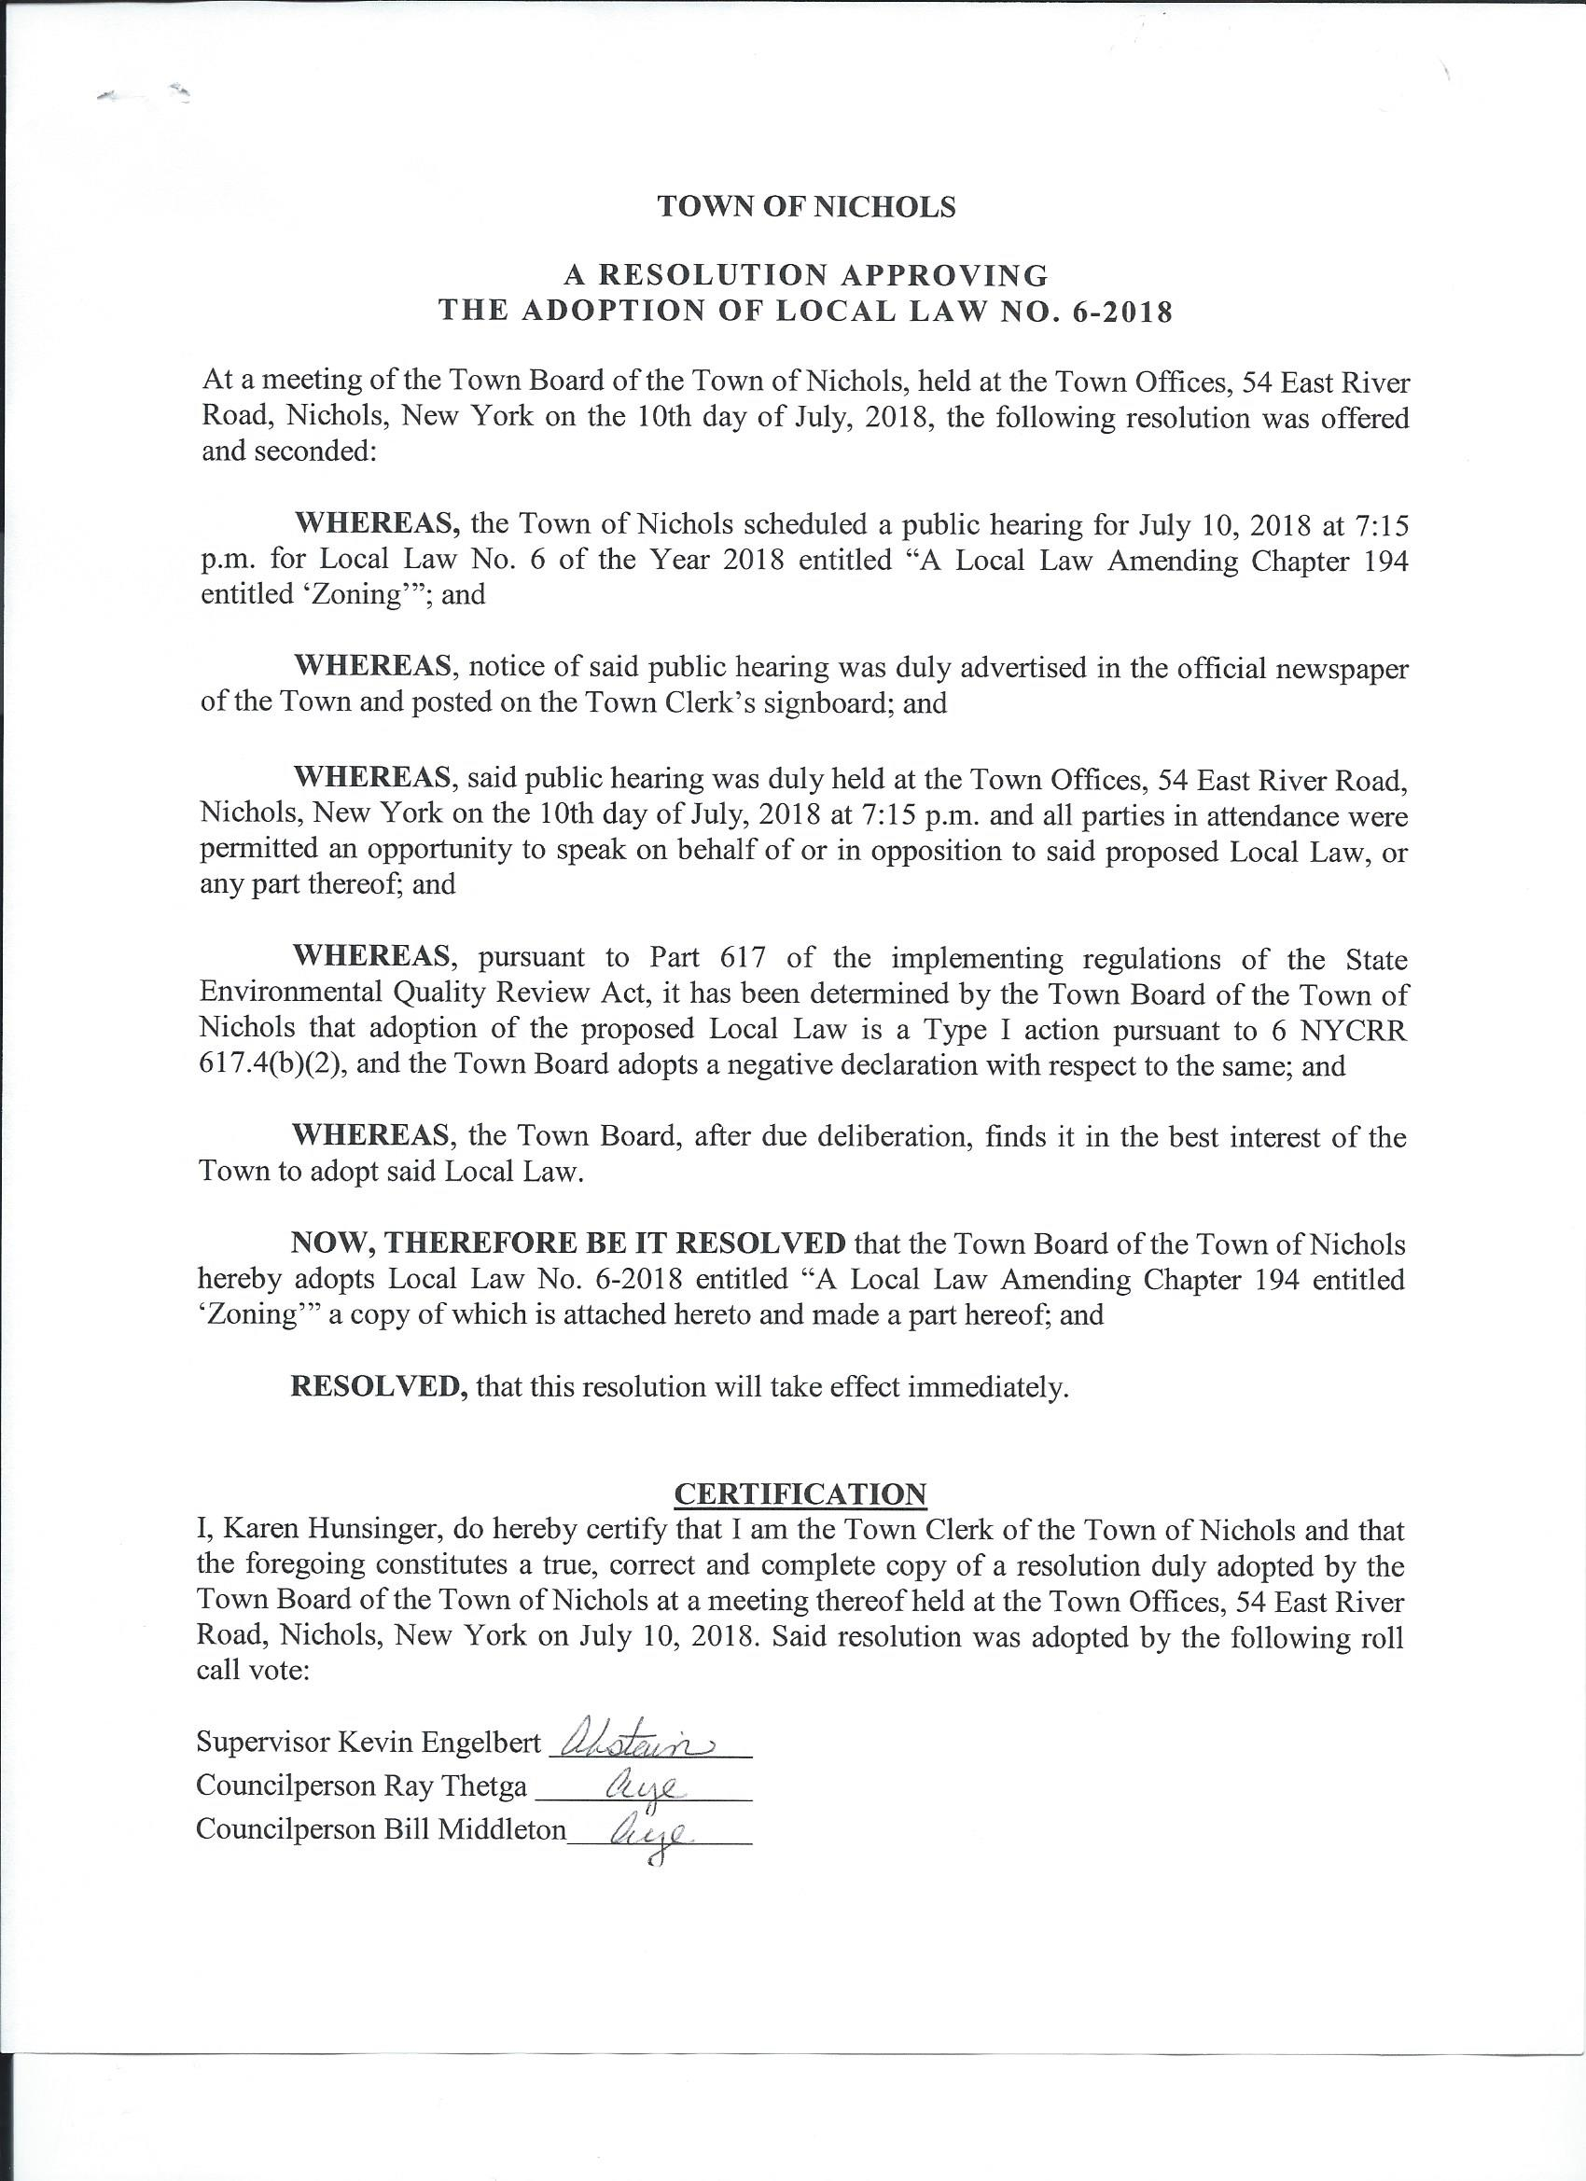

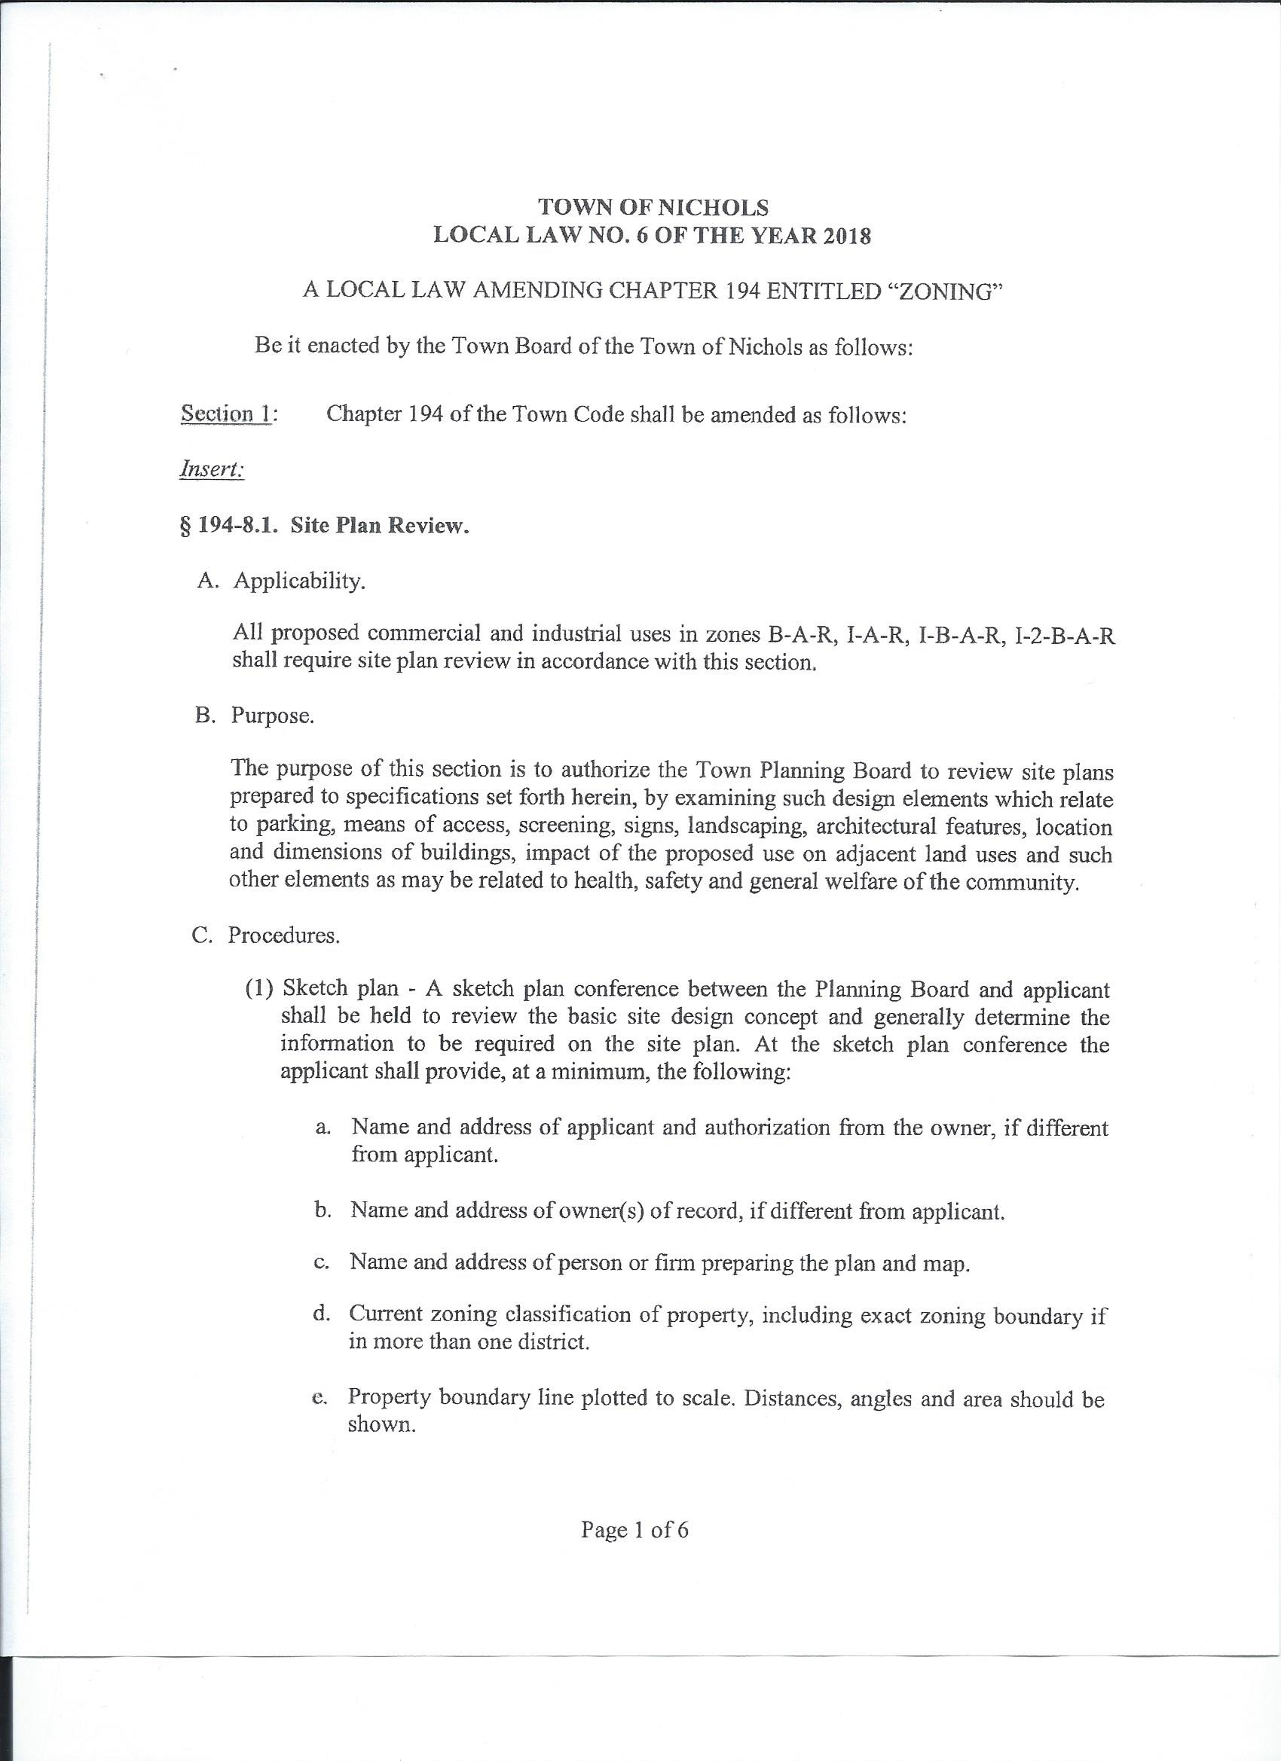
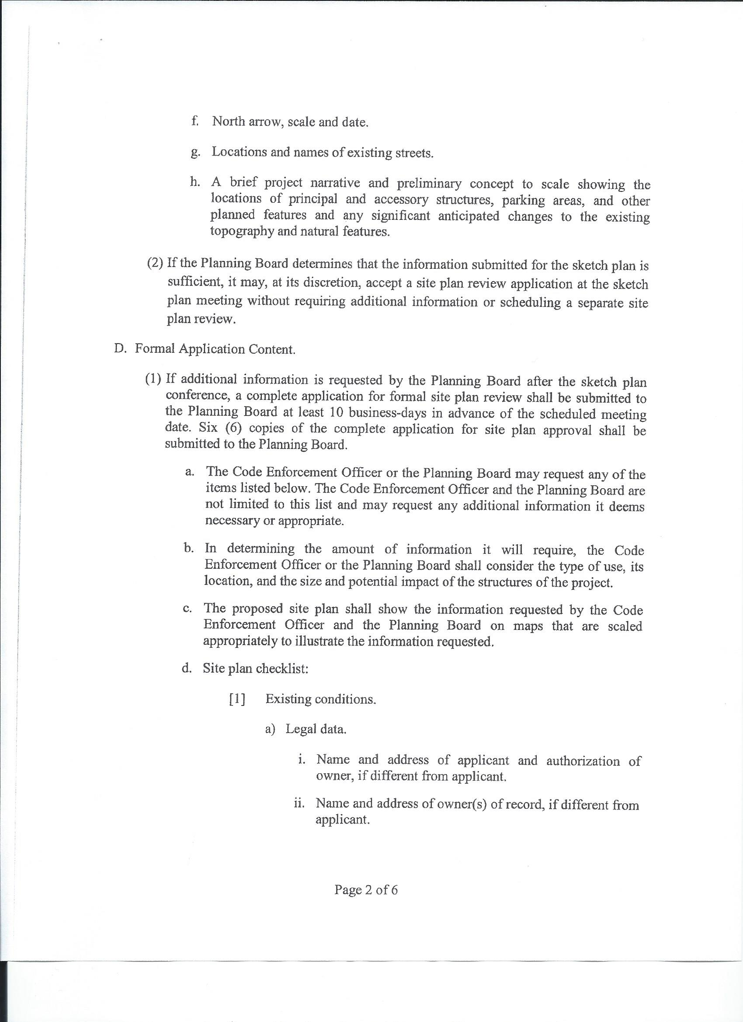
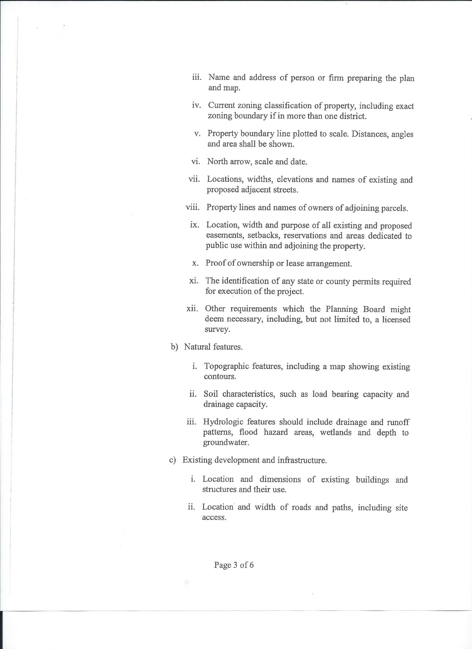
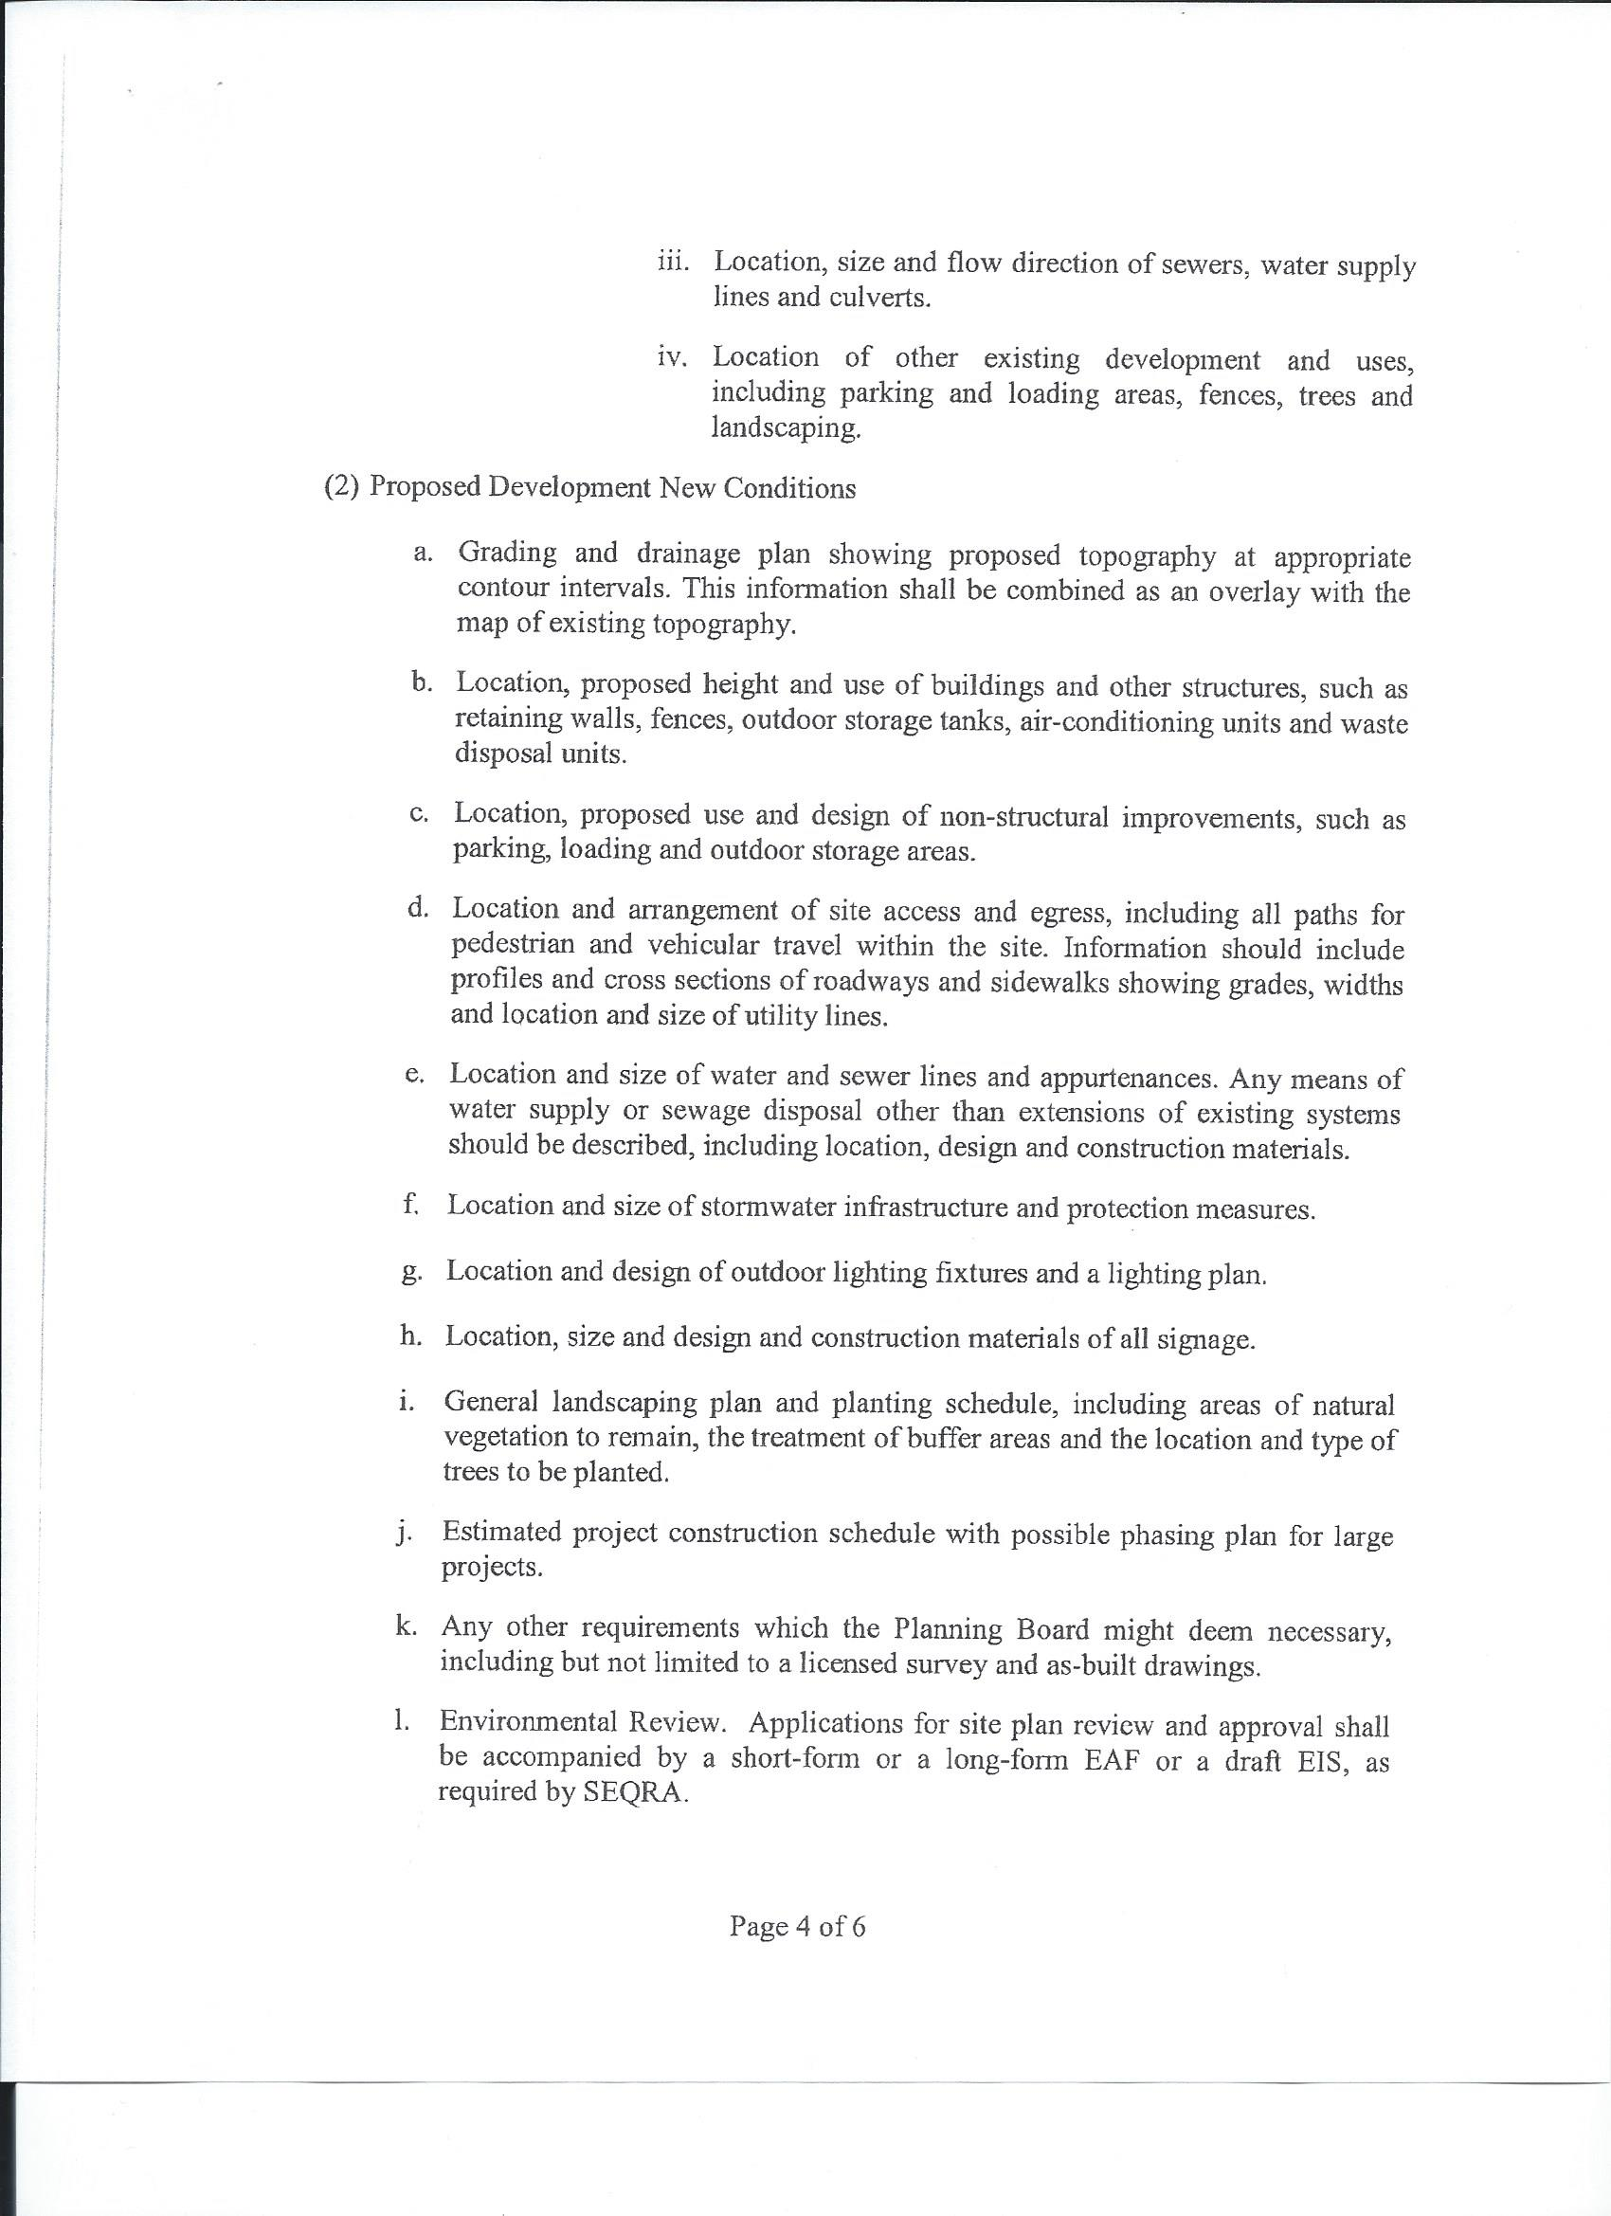
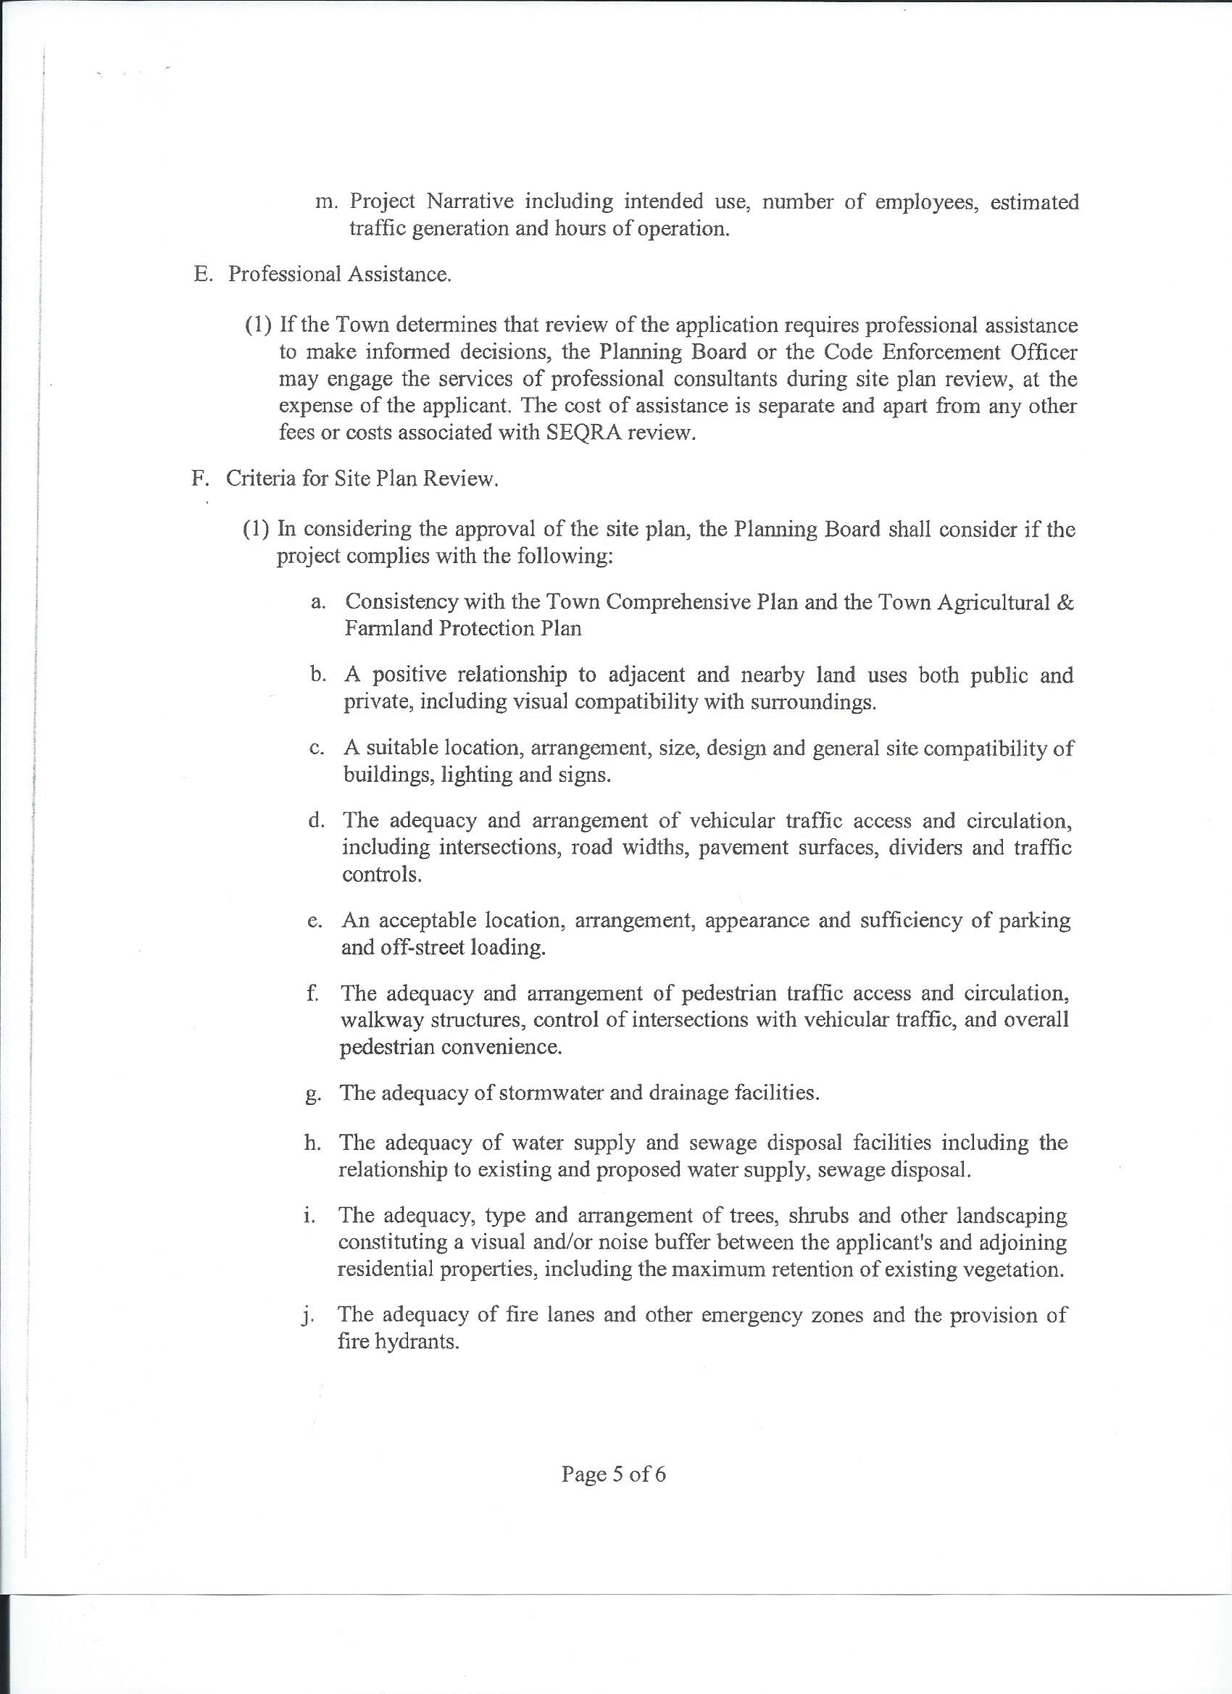
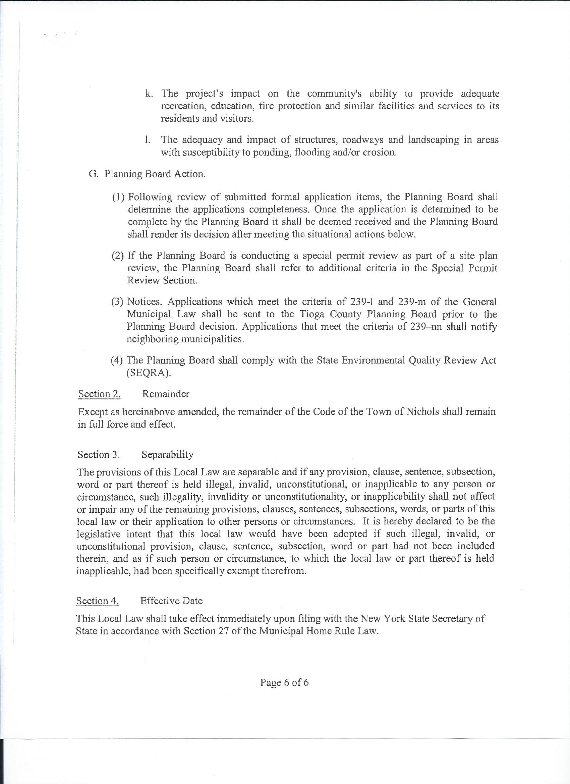
The motion to approve Local Law #6 –A Local Law Amending Chapter 194 Entitled “Zoning”
Was made by B. Middleton 2nd by B. Crannell
Roll Vote;
R. Thetga (aye), B. Middleton (aye), B. Crannell (aye), K. Engelbert (abstain). Carried 3-0-1-1

OTHER NEW BUSINESS FROM THE BOARD

UPDATE FROM TOWN DEPARTMENTS/PERSONNEL
- Highway – K. Vought –
Working on roads
- Planning Board – B. Crannell

OLD BUSINESS
- New York Rising – B. Crannell

- Comprehensive Plan – B. Crannell – meeting next week.

- Reap – B. Crannell – moving forward
- NY. Solar Guide Books- Guide lines for Solar Farming.

- Maintenance Position – B. Middleton
A discussion ensued for getting a full time maintenance person, to do general maintenance for the Town. This position may require the employee to pass the County Civil Service Test. This is something that will have to be looked into, and is determined on the basis of what type of work (job description) to be performed.
This will be readdressed at the July 25, meeting.

ACCEPT REPORTS/PAY BILLS
The motion to accept the reports and pay bills was made by B. Middleton 2nd by R. Thetga
Roll Vote;
R. Thetga (aye), B. Middleton (aye), B. Crannell (aye), K. Engelbert (aye) Carried 4-0 -1-0

ADDITIONAL COMMENTS, QUESTIONS & CRITICISMS FROM THE PUBLIC

EXECUTIVE SESSION

ADJOURN
The motion to adjourn the meeting at 9:10 pm, was made by K. Engelbert 2nd by R. Thetga
Roll Vote;
R. Thetga (aye), B. Middleton (aye), B. Crannell (aye), K. Engelbert (aye) Carried 4-0 -1-0
Karen Hunsinger
Town Clerk 07/16/2018

